Java NIO

An Implementation Case Study
Table of Contents

Introduction 3

Problem Description 3

Potential Solutions 3

What is NIO? 4

Non Blocking System Architecture 4

High Level Implementation details 5

General Algorithm for a Non Blocking Server 5

Algorithm Explanation 6

Threading In Multiplexing 6

SSL with Non Blocking I/O 7

Where does the SSL Engine fit In? 9

Conclusion: 10

References: 10

Introduction

Primitive Chat Applications are based on a Client-Server model where in the Chat Server services multiple clients by opening a dedicated Socket Connection and managing the connection through a dedicated thread. The real challenge arises when the server needs to scale up and manage a load of a few tens of thousands of such connections and threads. The traditional thread pooling approaches do not scale well, since the context switching time between them increases significantly with the number of threads and the CPU time is wasted too. Also the number of threads that can be spawned is dependent on factors like

- The physical memory available in the server where the application runs
- Virtual Memory and Swap Size allocation in the server
- The processing capability of the server.

It would not be feasible to continuously upgrade the hardware in the server to meet the increasing demand with respect to the thread handling capability. So there needs to be some mechanism or architectural approach in place, using which highly scalable servers can be built, managing several thousands of socket connections.

Problem Description

This was precisely the problem faced by the Client’s application. The application had a similar architecture as described above, and could cater to 8000 users or threads. Each user corresponds to an individual thread. There was a need for the application to scale up to 40000 users, without any performance or throughput degradation and hardware resizing.

Potential Solutions

There were two solutions to the above problem.

- Currently the application runs on Weblogic 8.1 and Solaris 8, with a 32 bit jvm. It was planned to upgrade the server version to Weblogic 9.2 with 64 bit jvm. 64 bit jvm would enable to address more memory space. Accordingly the enhanced memory address space can be effectively utilized to tune the heap size used by the Weblogic server. But this approach also has its own limitations in the number of threads that can be spawned. Effectively with 2GB heap size, the application could cater to only 20000 threads. The inherent memory footprint of the application was also a contributing factor in restricting the number of threads that can be spawned in the application. Increasing the heap size and hardware resizing was definitely not a robust and long term solution to the problem.

- I/O Multiplexing is the alternative to thread pooling. In this approach, a single thread is used to handle an arbitrary number of sockets. This allows servers to keep their thread count low, even when operating on thousands of sockets, thereby improving scalability and performance significantly. The support for I/O multiplexing is a feature of Java 1.4. It builds on two features of the Java NIO (New I/O) API: selectors and non-blocking I/O.

What is NIO?

NIO is New Input/Output, which supports Non Blocking Sockets. A nonblocking socket allows input/output operation on a channel without blocking the processes using it. In simple words, in the case of Blocking Sockets (regular plain sockets), the thread/process execution on an established socket connection would wait (block) whenever an I/O operation like Socket Read/ Socket Write is attempted at. The thread/process will not be able to perform any other operation. If there is a requirement to develop a server accepting diverse client connections and process multiple requests simultaneously, then there needs to be a multithreaded server that manually handles a thread for each connection. In which case, the whole thread-management solution, with related concurrency and conflict troubles needs to be handled by the application itself. NIO solves this problem. With nonblocking sockets, a nonblocking server can be implemented without getting into the common multithreading hassles. If at all there needs to be some multithreaded programming done, it would be on top of the NIO component developed, for better scalability and performance.

Non Blocking System Architecture

Figure 1 illustrates the architecture of a system using nonblocking sockets.

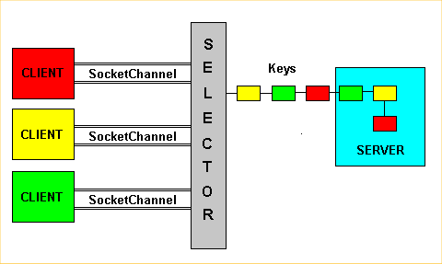
Figure 1. Nonblocking socket architecture

The various components involved in a typical Non Blocking System are

- Server: The application receiving client requests.
- Client : The set of applications sending requests to the server.
- Socket channel: The communication channel between client and server. It is identified by the server IP address and the port number. Data passes through the socket channel by buffer items.
- Selector: The main object of all non blocking technology. It monitors the recorded socket channels and serializes the requests, which the server has to satisfy.
- Keys: The objects used by the selector to sort the requests. Each key represents a single client sub-request and contains information to identify the client and the type of the request.
The client applications simultaneously perform requests to the server. The Selector collects them, creates the keys, and sends them to the server. This may seem like a blocking system, because the requests are processed one at a time, while actually it is not. In fact, each key doesn't represent the entire information stream a client sends to a server, but just a part. The selector divides the client-data in sub-requests identified by the keys. Consequently, if more clients continuously send data to the server, the selector will create more keys, which will be processed according to a time-sharing policy. To emphasize that, in Figure 1 the keys have the same color of their related clients.

High Level Implementation details
The socket channels are instances of the new SocketChannel class, which allow transferring data through the net. The SocketChannel class is defined in the java.nio.channel package. The selector is a Selector class object. Each instance of Selector can monitor more socket channels, and thus more connections. When something interesting happens on the channel (for example, a client attempting a connection or a read/write operation), the selector informs the application to process the request. The selector does that by creating the keys, which are instances of the SelectionKey class. Each key holds information about the application making the request and the type of the request. The type can be one of the following:
- Attempting connection (by the client)
- Accepting connection (by the server)
- Reading operation
- Writing operation

General Algorithm for a Non Blocking Server
A general algorithm for a nonblocking server could be as follows
create SocketChannel;
create Selector
associate the SocketChannel to the Selector
for(;;) {
waiting events from the Selector;
event arrived; create keys;
for each key created by Selector {
check the type of request;
isAcceptable:
get the client SocketChannel;
associate that SocketChannel to the Selector;
record it for read/write operations
continue;
isReadable:
get the client SocketChannel;
read from the socket;
continue;
isWriteable:
get the client SocketChannel;
write on the socket;
continue;
}
}

Algorithm Explanation
Basically, the server implementation consists of an infinite loop in which the selector waits for events and creates the keys. According to the key-types, an opportune operation is performed. There are four possible types for a key:
- Acceptable: the associated client requests a connection.
- Connectable: the server accepted the connection.
- Readable: the server can read.
- Writeable: the server can write.
Usually an acceptable key is created on the server side. In fact, this kind of key simply informs the server that a client required a connection. In this circumstance, as you can see by the algorithm, the server individuates the socket channel and associates this to the selector for read/write operations. From this moment, when the accepted client reads or writes something, the selector will create readable or writeable keys for that client. Hence, the server will intercept those keys and perform the right actions.

Threading In Multiplexing
Typically a single thread handling several thousands of clients is not a good design. It would also not take the full advantage of systems with multiple CPUs. There fore there needs to be an architecture, by way of which the work is divided among many threads. The right threading model would be the M dispatchers/N workers model, where there are multiple event dispatch threads and multiple worker threads. All the incoming connections are assigned to an event dispatch thread (Selector Thread). Once assigned, the later read/write processing is delegated to worker threads.
The component developed on top of the basic NIO model to take care of this multithreaded architecture is based on the Reactor Pattern.
The below pattern, as shown in Figure 2, is what was exactly followed in the NIO server implementation.

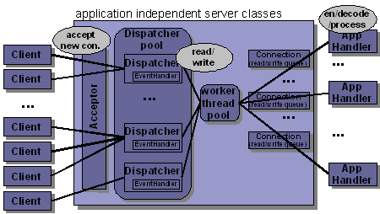
Figure 2: Reactor Pattern.
Every new client connection of a server will be accepted by the single Acceptor, which is bound to the server port. The Acceptor is a single threaded active class. Because it is only responsible for handling the very short-running client connection request, it is often sufficient to implement the Acceptor using the blocking I/O model. The Acceptor gets the handle of a new connection by calling the ServerSocketChannel's blocking accept method. The new connection will be registered to a Dispatcher. After this, the connection participates in event handling. Based on whether the readiness event is read/write, the corresponding event handlers are fired. The event handlers further delegate the processing to a worker thread pool to which there are a number of worker threads registered. The specific task that needs to be performed after a read/write event is done by application level event handlers which are in turn called by the worker threads.

SSL with Non Blocking I/O
With the traditional blocking sockets API, security is a simple issue: just set up an SSLContext instance with the appropriate key material, use it to create instances of SSLSocketFactory or SSLServerSocketFactory, and finally use these factories to create instances of SSLServerSocket or SSLSocket. With NIO, with all the socket channels, selectors and buffers, there is nothing like SSLSocketChannel introduced, to implement SSL with NIO. Instead Sun came up with the introduction of the SSLEngine API released with JDK 1.5. The SSLEngine API is transport-independent, thereby completely separating the SSL support from IO. The SSL Engine API is only responsible for implementing the SSL/TLS state machine, which performs all communication with the outside world using byte buffers. Therefore, the developer is free to use any transport mechanism he finds appropriate. Unlike the traditional stream based API, the developer now needs to take care of handshaking and reassembling SSL packets before decrypting them.
Figure 3 below explains the life cycle of an SSLEngine. It is self explanatory

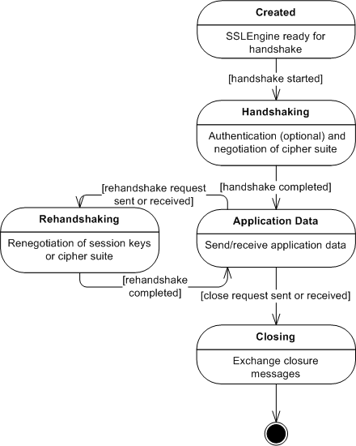

Figure 3: Life Cycle of an SSL Engine

Where does the SSL Engine fit In?

Figure 4 explains the interaction of the SSLEngine with the other applications. The two main methods of the SSLEngine are wrap() and unwrap().SSLEngine.wrap() receives plaintext data from the application and encrypts it. It may also generate handshake data, if a handshake is in progress. The result, containing both encrypted application data and handshake data, is given back to the application in order to be sent to the peer. On the opposite direction, SSLEngine.unwrap() processes data read from the network, which may include handshake and encrypted application data. The handshake data is used to update the internal state of the SSLEngine and the application data is decrypted and passed to the application. As a result of this behavior, a typical application will have the following four buffers:

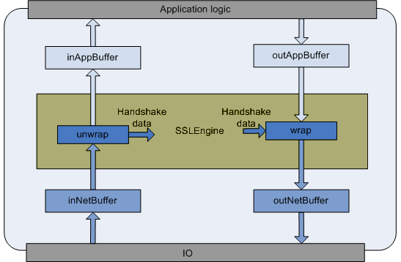
Figure 4: Where SSLEngine Exactly Fits in

inNetData
Stores data received directly from the network. This consists of encrypted data and handshake information. This buffer is filled with data read from the socket and emptied by SSLEngine.unwrap().

inAppData
Stores decrypted data received from the peer. This buffer is filled by SSLEngine.unwrap() with decrypted application data and emptied by the application.

outAppData
Stores decrypted application data that is to be sent to the other peer. The application fills this buffer, which is then emptied by SSLEngine.wrap().

outNetData
Stores data that is to be sent to the network, including handshake and encrypted application data. This buffer is filled by SSLEngine.wrap() and emptied by writing it to the network.

There are basically 2 types of statuses as a result of an SSLEngine Operation

- The overall status information is used to notify the developer of the result of the last operation attempted by the engine.

- The handshake status is used to inform about any handshake that may be in progress.

The result of a wrap()/unwrap() call also contains the number of bytes consumed and produced.

Conclusion:
On Load Testing, with NIO, the application could cater to 38000 clients, with the same memory and hardware configuration as against 20000 clients with the Plain Socket Based Implementation. The only difficulty would be to implement the SSLEngine wrapper, because of its complicated implementation, but with NIO, there is no other option left out, other than getting the hands a little dirty. Whether to go for a NIO based implementation or not, is a decision to be made based on the number of simultaneous clients to be handled. If there is a need to support a few thousands of simultaneous clients, one should definitely consider using I/O Multiplexing with the NIO approach.

References:
- Java NIO – O’Reilly
- http://java.sun.com/j2se/1.4.2/docs/guide/nio/
- http://www.onjava.com/pub/a/onjava/2004/09/01/nio.html
- http://today.java.net/pub/a/today/2007/02/13/architecture-of-highly-scalable-nio-server.html
- http://www.exampledepot.com/egs/java.nio/pkg.html
- http://java.sun.com/j2se/1.5.0/docs/api/javax/net/ssl/SSLEngine.html
- http://www.onjava.com/pub/a/onjava/2004/11/03/ssl-nio.html

